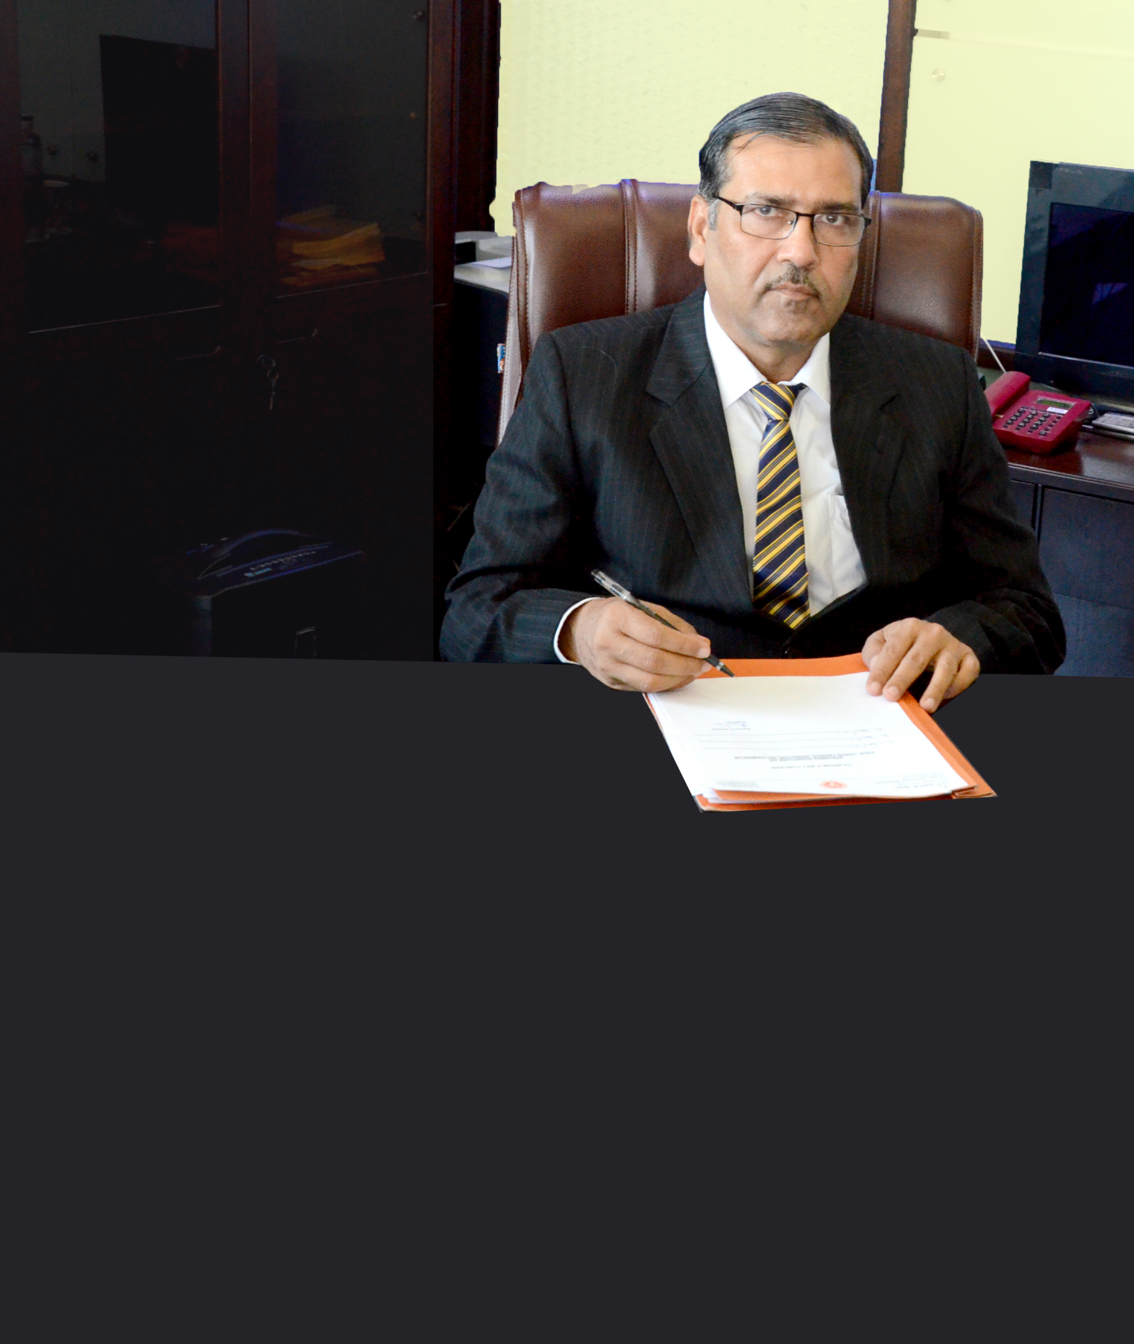

National Institute of Technology Hamirpur (Himachal Pradesh) is one of the premier engineering institution in the country and produces world class graduates and post graduates year after year.

Our graduates are an integral part of India's growth story. The nation's best education system, along with the finest facilities has ensured that our students achieve excellence in their chosen fields.

The students graduated by our institute have been making an edible impact on the industry and institutions in which they have been selected. All of our students are groomed in a manner which

gives them a perfect combination of technical intellect and social awareness thus fostering the spirit of national integration among the students, a close interaction with industry and a strong emphasis on research, both basic and applied.

I am certain that our students will find their dream jobs. Equally, I am sure the organizations will appreciate the association of our students.

I wish each and every student all the best for Placement in the academic year 2018-19.

Best Regards,

Prof. Vinod Yadava